**STEPPER MOTOR**

**NEMA**

The “**National Electrical Manufacturers Association**” (**NEMA**) sets standards for many electrical products, including step motors. Generally, the NEMA *number* of a given motor represents the motor housing's face width in inches, increased by a factor of 10. For instance, a NEMA 14 motor is 1.4 inches, a NEMA 17 is 1.7 inches, and a NEMA 23 is 2.3 inches.

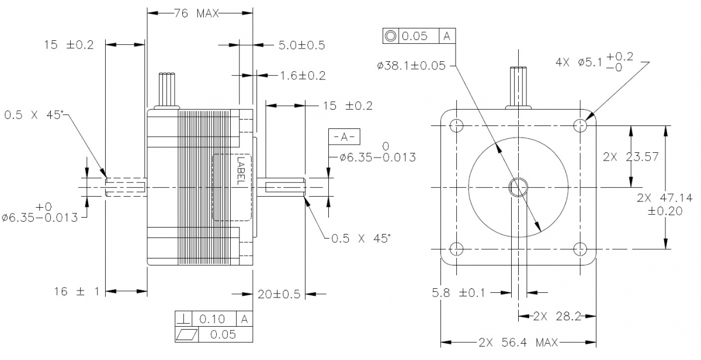

Fig: NEMA 23

#### NEMA Stepper Motors:

1. **NEMA 8**
2. **NEMA 11**
3. **NEMA 14**
4. **NEMA 17**
5. **NEMA 23**
6. **NEMA 24**
7. **NEMA 34**
8. **NEMA 42**

Here's a table listing the companies that produce NEMA stepper motors:

|  |  |  |
| --- | --- | --- |
| Company Name | Website | Product Range |
| Moons' Industries | https://www.moonsindustries.com | NEMA 8, 11, 14, 17, 23, 24, 34, 42 |
| Oriental Motor | https://www.orientalmotor.com | NEMA 8, 11, 14, 17, 23, 24, 34, 42 |
| Sanyo Denki | https://www.sanyodenki.com | NEMA 17, 23, 34 |
| Lin Engineering | https://www.linengineering.com | NEMA 8, 11, 14, 17, 23, 34 |
| Applied Motion Products | https://www.applied-motion.com | NEMA 8, 11, 14, 17, 23, 24, 34, 42 |
| Phidgets | https://www.phidgets.com | NEMA 17, 23 |
| AutomationDirect | https://www.automationdirect.com | NEMA 17, 23, 34 |
| Nanotec | https://www.nanotec.com | NEMA 8, 11, 14, 17, 23, 24, 34, 42 |
| StepperOnline | https://www.omc-stepperonline.com | NEMA 8, 11, 14, 17, 23, 24, 34, 42 |
| Leadshine | http://www.leadshine.com | NEMA 8, 11, 14, 17, 23, 24, 34 |
| Pololu | https://www.pololu.com | NEMA 8, 11, 14, 17, 23 |
| Teknic | https://www.teknic.com | NEMA 17, 23, 34 |
| Astrosyn | https://www.astrosyn.com | NEMA 8, 11, 14, 17, 23, 34 |
| Nidec | https://www.nidec.com | NEMA 17, 23, 34 |

**High Torque NEMA Stepper Motors:**

* **NEMA 17**: Typically offers up to 65 oz-in torque.
* **NEMA 23**: Can offer up to 270 oz-in torque.
* **NEMA 24**: Can offer up to 400 oz-in torque.
* **NEMA 34**: Can offer up to 1200 oz-in torque.

#### Other Stepper Motors:

1. **Moons' MS23HA6P4200**
2. **Nanotec ST5918L3008-A**
3. **Trinamic QSH6018**
4. **Oriental Motor PK266-02A**
5. **Oriental Motor PK268-02B**
6. **Sanyo Denki 103H7126-0640**
7. **Leadshine 57HS22**
8. **Leadshine 86HS45**
9. Minebea 17PM-J
10. Portescap 26M048B1B
11. Haydon Kerk 19000 Series
12. Phytron ZSS Series
13. Nanotec PD4-C Series
14. Oriental Motor CRK Series

**Conclusion**

**Criteria for Selection:**

1. Torque Requirement: Stepper motors need sufficient torque to lift and hold the 1kg weight reliably. Higher torque motors can handle heavier loads more effectively.

2. Size and Weight: Motors should be compact and lightweight to fit within the constraints of the robotic arm without adding excessive weight.

3. Power and Voltage Requirements: Ensure the motors can operate within your desired voltage range and provide adequate power for the application.

4. Step Angle and Precision: Lower step angles provide finer resolution and smoother motion, which is crucial for precise robotic movements.

**Motors:**

Based on the criteria and typical specifications from the list provided, here are three recommended stepper motors:

1. NEMA 17 Stepper Motors:

* Reasoning: NEMA 17 motors are widely used in robotics due to a good balance of torque, size, and power efficiency.
* Key Features:
* Holding Torque: Typically ranges from 0.4 to 0.6 kg-cm, adequate for lifting 1kg.
* Step Angle: 1.8 degrees (200 steps per revolution) provides good positional accuracy.
* Size: Compact and lightweight, suitable for integration into a robotic arm without adding excessive bulk.
* Power Efficiency: Operates efficiently within a moderate voltage range (usually 12V to 24V).

2. NEMA 23 Stepper Motors:

* Reasoning: NEMA 23 motors offer higher torque compared to NEMA 17, providing more lifting power.
* Key Features:
* Holding Torque: Typically ranges from 1.2 to 1.8 kg-cm, offering greater torque for heavier loads.
* Step Angle: 1.8 degrees, similar to NEMA 17, ensuring comparable positional accuracy.
* Size: Slightly larger than NEMA 17 but still manageable for robotic arm applications.
* Power Efficiency: Suitable for higher voltage applications (up to 48V) if needed.

3. NEMA 24 Stepper Motors:

* Reasoning: NEMA 24 motors provide even higher torque, suitable if the arm design requires significant lifting capability.
* Key Features:
* Holding Torque: Ranges from 3 to 12 kg-cm, offering robust torque for lifting heavier loads.
* Step Angle: 1.8 degrees, maintaining good precision in positioning.
* Size: Larger and heavier than NEMA 17 and 23, suitable if space permits and for applications needing more power.
* Power Efficiency: Operates efficiently within a voltage range similar to NEMA 23 (up to 48V).

**Conclusion:**

For robotic arm project aiming to lift a 1kg weight, NEMA 17 stepper motors are likely the best choice due to their balanced performance in terms of torque, size, and power efficiency. They should be able to handle the load effectively while maintaining precise control over the arm movements.

NEMA 23 motors could be considered if you anticipate needing more torque for future upgrades or heavier payloads.

NEMA 24 motors would be overkill unless your design specifically requires very high torque capabilities.